KENDRIYA VIDYALAYA TAMENGLONG

Summative Assessment II (2015-16)

Subject: E V S Time: 02 Hours

Class: III Date:

Name : ................................. Roll no…………

|  |  |  |  |  |
| --- | --- | --- | --- | --- |
| COMPETENCY | OBSERVATION(20) | IDENTIFICATION(20) | DISOVERY OF FACTS(20) | TOTAL(60) |
| VALUE POINTS |  |  |  |  |
| GRADE |  |  |  |  |

Sign of invigilator sign of evaluator.

**OBSERVATION**

*1. Observe the pictures and answer the following questions.*

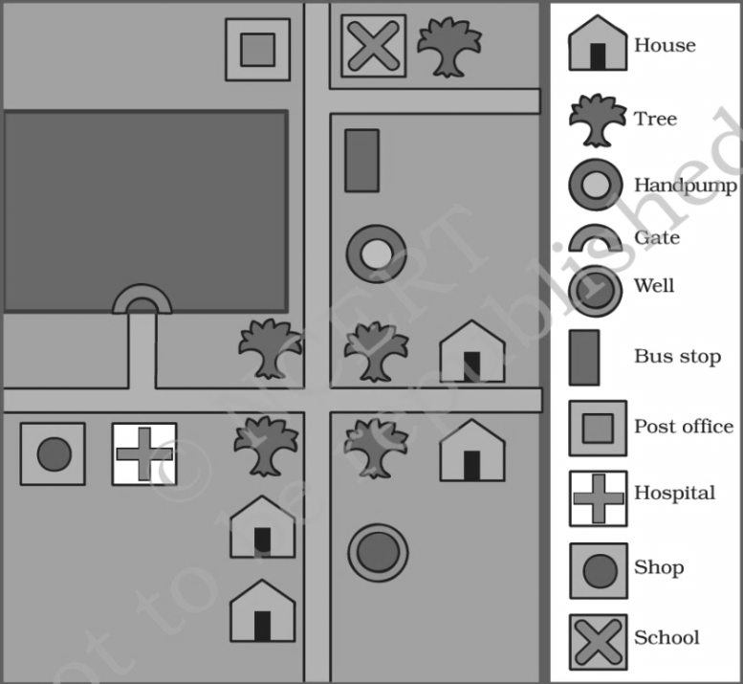a. How many handpumps are there in the map?

Ans:_______________

b. How many trees are there in the map?

Ans:_______________

c.What is near to the shop?

Ans:_______________

d.Is the bus stop closer to the school or to the hospital?

Ans:_______________

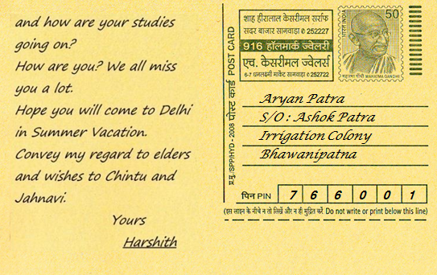e.Who has written this letter?

Ans : _____________________

f.To whom has it been written?

Ans : ____________________

g. What is the PIN written on the

postcard?

Ans ___________________________

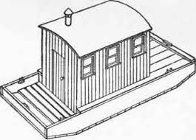**2.Answer the following questions.**

a. i) Name the picture. Ans________________

ii) How is it different from our house ?

______________________________________________________________

_______________________________________________________________

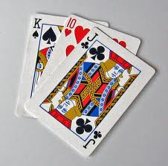b.i) Name the game.

Ans_____________________

ii) What type of game is it?

Ans ________________(indoor/outdoor)

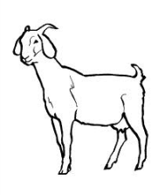

**c**. i)Name the animal.

Ans. __________________

ii)What does it eat?

Ans. ____________________________________

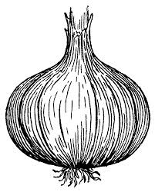

**d.**i) Name the picture.

Ans. ___________________

ii) Which part of the plant is it?

Ans. _____________________________________

3. What is the braille script ?

Ans.________________________________________________________________________________________________________________________________________________________________________________________________________________________________________________________

4. Who is the father of the braille script ?

Ans.______________________________________________________________

5. Name different types of houses.

Ans._____________________ ______________________________

____________________ _______________________________

**IDENTIFICATION AND CLASSIFICATION**

*1.Choose the correct option and fill in the blanks.*

a. ____________ is an indoor game. (Ludo,Cricket,Football)

b. The food item that we get from plant is __________.

(egg, milk, potato)

c. The person who repairs cars and scooter is called ____________.

(blacksmith, goldsmith, mechanic)

d. We take __________ when we have a toothache.(ajwain, clove, tulsi)

e. The sense organ which helps us smells ____________.

(nose, tongue , ear)

2. Name six different types of pots made of clay.

____________________ _______________________

____________________ _______________________

3.Name four animals that we cannot touch.

______________________ ________________________

______________________ ________________________

4. Write the names of four means of communication.

______________________ ________________________

______________________ ________________________

5. Write the names of things required to play the following games.

Cricket- _________________________________________________

Carrom- _________________________________________________

6. *Write true or false against the following statements.*

(i)The family members love each other very much. [ ]

(ii)Lion is a pet animal that we keep in our house. [ ]

(iii)The body of a letter box is red and its top is black. [ ]

(iv)Letters are sorted in the police station. [ ]

**3.Classify the following animals based on what they eat.**

**(Cow, Tiger, Wolf, Deer, Elephant, Hyena , Goat , Zebra , Leopard, Lion)**

|  |  |
| --- | --- |
| FLESH EATERS | PLANT EATERS |
|  |  |
|  |  |
|  |  |
|  |  |
|  |  |

**DISCOVERY OF FACTS**

**1. What do these symbols stand for?**

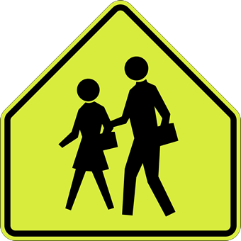

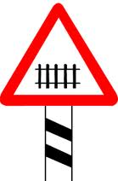_________________ __________________ _________________________

____________________ ________________________

**2. Answer these following questions.**

a. What type of clothes do you wear in summer?

__________________________________________________________________

b. Name the materials that are needed to build a house.

1. From which animals do we get the following?

|  |  |
| --- | --- |
| Wool |  |
| Milk |  |
| Honey |  |
| Egg |  |

1. Write names of four unstitched clothes.

_____________________ ______________________

_____________________ ______________________

Complete this food chain.

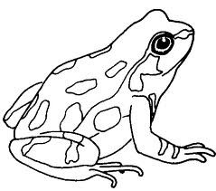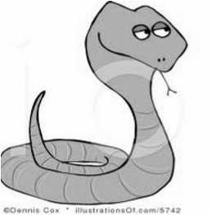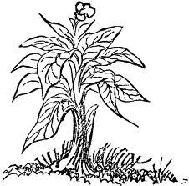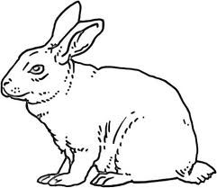

2. Draw the picture of your house .